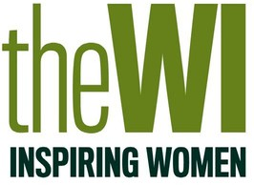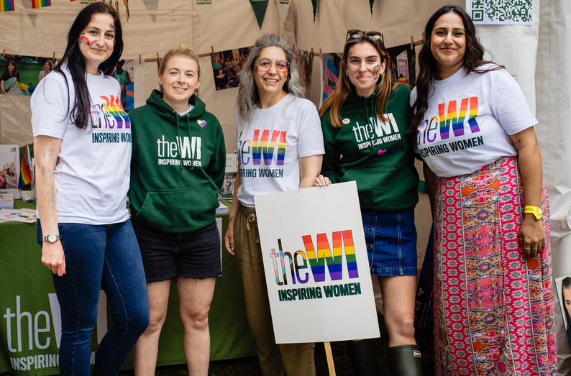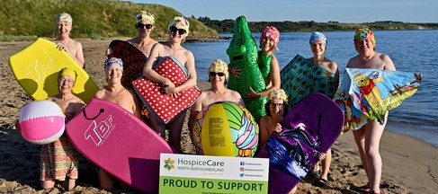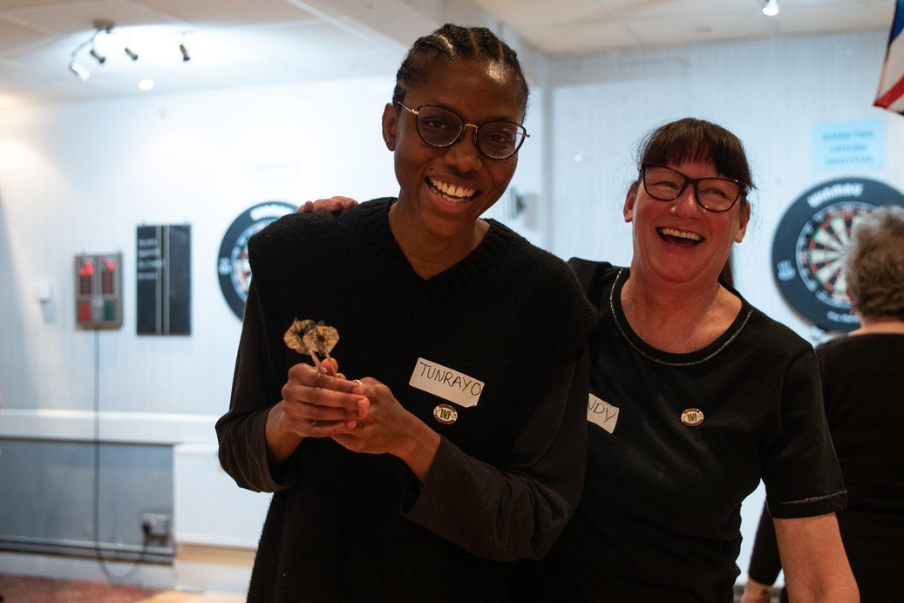THE WI RECRUITMENT GUIDE

WI Recruitment Guide

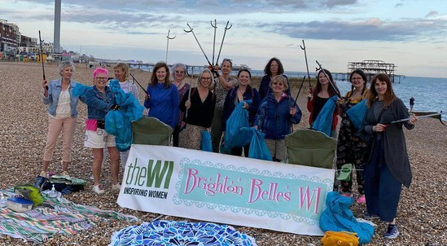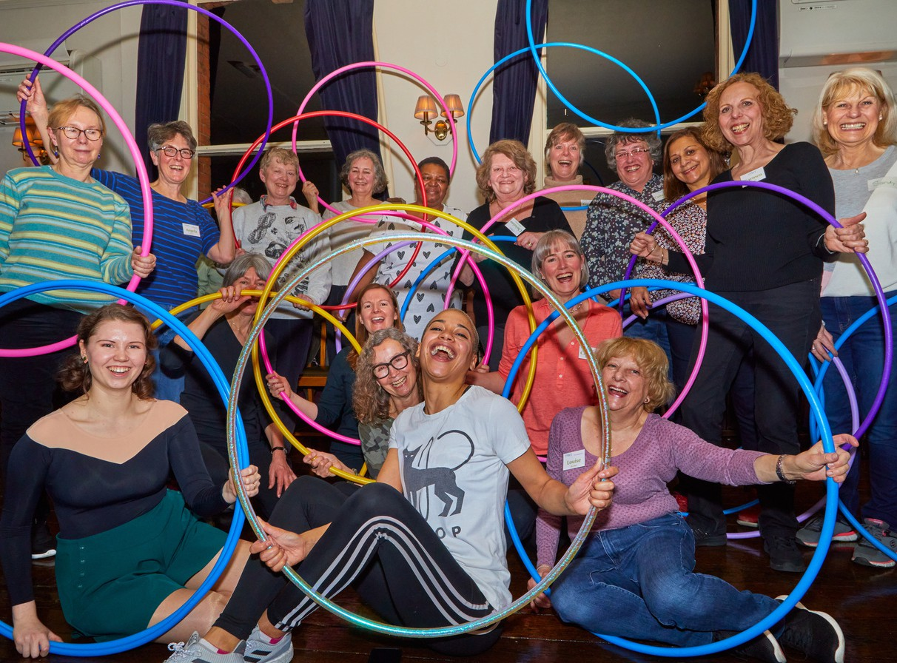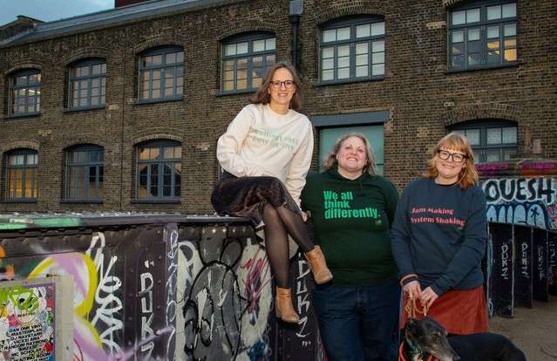CONTENTS

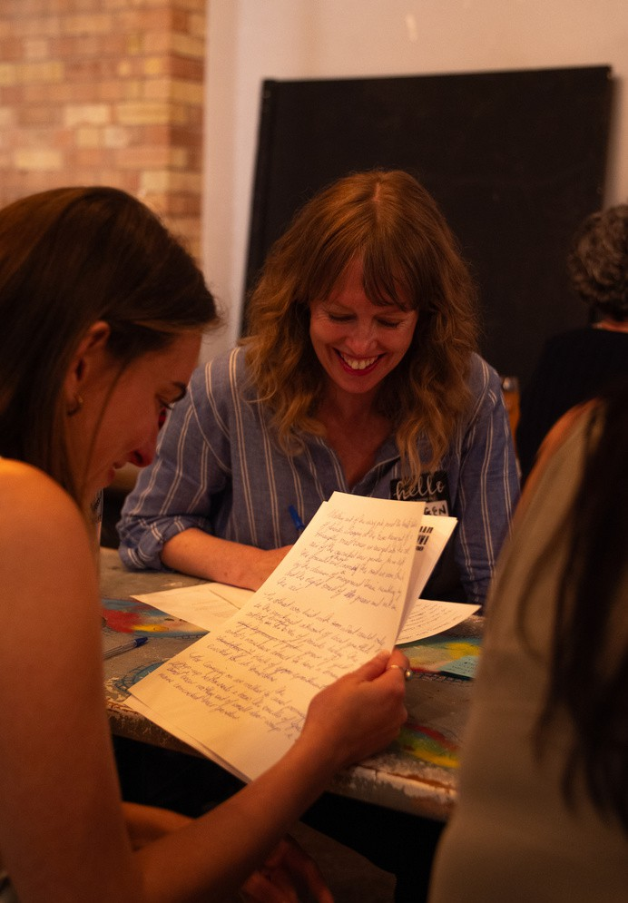

**Photographer: Izzie Jones**

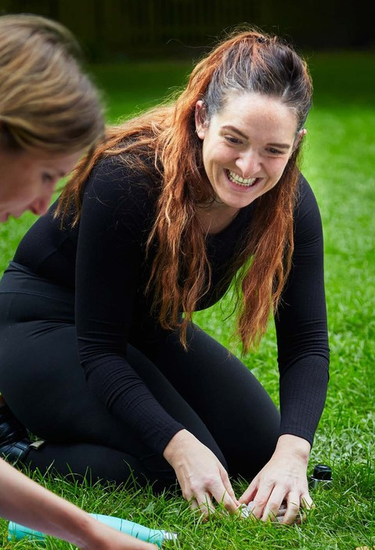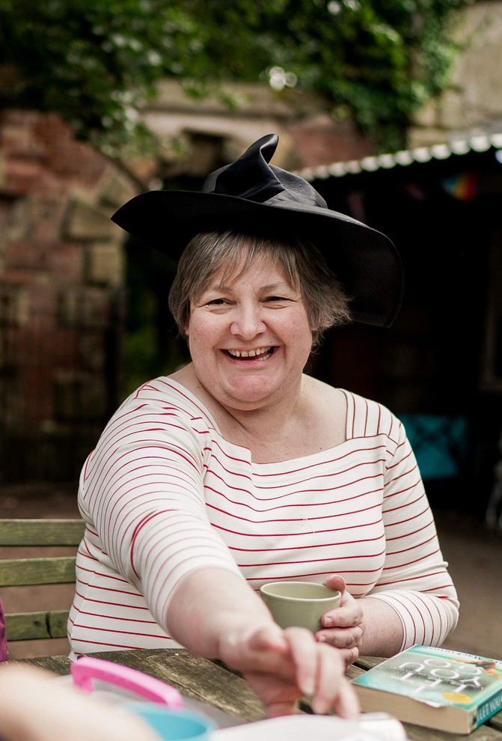

**Photographer: Frank Wood**

**3**

1. Introduction 3
2. Questions to think about before recruiting 4
3. Top tips for recruitment 5
4. Creating recruitment materials 6
   1. Printing guidelines 6
   2. Canva - an online graphic design tool 6
   3. Mailchimp 6
5. Where to leave recruitment materials 7
6. Recruiting via local groups 8
7. Recruiting at events where the WI has a stall 9
8. Domain names 10
9. Language 11
10. The WI Vision 12
11. The WI Strategy 13
12. What next? 14
13. Other resources 15
14. Contact us 16
15. Updating this guide 16

This guide is full of tips and reminders of things to do and be aware of when out recruiting for new members. There are also suggestions of possible groups in the local area to reach out to.

WI Recruitment Guide

WI Recruitment Guide

1. INTRODUCTION

2. QUESTIONS TO THINK ABOUT

BEFORE RECRUITING

**4**

**3**

If there is anything your WI or federation has found useful for recruitment and could be shared with others within this guide, please get in touch using the contact details at the end of this guide.

Everyone always says the WI is a great place to meet new people and recruitment is a part of that so have some fun getting out there and getting to know other women in your community!

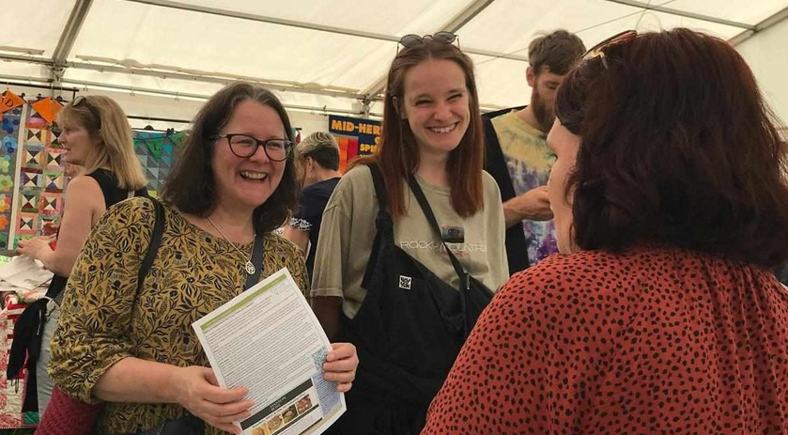

What are your WI’s unique selling points? Think about what your current members enjoy about your WI, why they joined and what they bring to the WI experience. You might have some interesting sub-groups or arrange trips to different places. Whatever it is, make a list so that you can shout about how great your WI is!

Does your WI have a [Welcoming Team](https://mywi.thewi.org.uk/running-your-wi/members-resources/wi-welcoming-teams)? This is a team who are dedicated to looking after new members. They can also be a good point of contact for current members.

Is your meeting venue at full capacity? Have you checked your finances to see whether hiring a bigger venue may be possible?

Have you thought about having [hybrid](https://mywi.thewi.org.uk/running-your-wi/guide-to-running-meetings/hosting-a-hybrid-wi-meeting) [meetings](https://mywi.thewi.org.uk/running-your-wi/guide-to-running-meetings/hosting-a-hybrid-wi-meeting)? A hybrid meeting is when some of the members join into the meeting physically and others can join virtually.

Have you thought about having some [meetings and/or sub groups online](https://mywi.thewi.org.uk/running-your-wi/guide-to-running-meetings/virtual-meetings)?

Are your meeting times flexible? Could you possibly have half the meetings in the evening and half in the afternoon?

Does your WI have a waiting list? Is there someone in charge of keeping track of this and keeping in touch with the potential members on the waiting list? Have you thought about pointing those on the waiting list to join as a WI Supporter?

Does your WI have a generic email address which is easier for potential members to remember and use?

How accessible is your physical meeting venue and how do you tell current/potential members about this? For example, you may have:

 accessible lift (including accessible lift buttons)

 accessible path to the building  accessible parking

 accessible toilet

 accessible toilet with baby changing facilities

 appropriate space and the provision of water bowls for assistance dogs

 automatic doors

 clear signage to the meeting room, toilets, fire exit etc

 drop off area close to the main door

 fire escape routes for people with mobility issues

 hearing loop

 steps with no ramp available  steps with ramp available

 steps with ramp and handrails available  wide doorways

 vibrating and light fire alarms (for people with hearing loss)

 for virtual meetings, consider the online platform you use and whether this has accessibility features such as subtitles.

**Please make sure your WI’s accessibility information is on the MCS and on any information, for new members such as welcome emails.**

[Create](https://twitter.com/womensinstitute) soci[al media ac](https://www.instagram.com/womensinstitute/)counts such as [Facebook,](https://www.facebook.com/thewi) [Bluesky](https://bsky.app/profile/womensinstitute.bsky.social) and [Instagram](https://www.instagram.com/womensinstitute/) and regularly post on them. See the [WI Social Media Guide](https://mywi.thewi.org.uk/Publicising-your-WI/resources-and-guidance/online-promotion/social-media-downloads/Social-Media-Guide-April-2023.pdf). Get your members, friends and family to like and follow your accounts, as well as sharing your posts. You can also tell local community groups about your WI by posting on their social media pages.

WI Recruitment Guide

WI Recruitment Guide

1. TOP TIPS FOR RECRUITMENT
2. CREATING RECRUITMENT MATERIALS

**6**

**5**

Open up some of your meetings and events to non-members so they can get a taste of your WI.

Encourage members to bring a friend along to a meeting.

Join the [WI Wanderers](https://www.facebook.com/groups/wiwanderers/?locale=en_GB) and the [Unofficial WI](https://www.facebook.com/groups/UnofficialWomensInstitute?locale=en_GB) [Facebook group](https://www.facebook.com/groups/UnofficialWomensInstitute?locale=en_GB) and post about your WI.

Create a website for your WI.

Make sure all details are up to date on your WI’s or Federation’s area on the NFWI website.

Join meetings and/events with other WIs in the area, or with WIs from a neighbouring federation.

Get in touch with your federation office and find out if they have promotional materials you can use.

Make sure a few members are assigned to go back and check the posters and leaflets your WI has put up in various places to make sure they still look good and have up to date information on them.

Use quotes from current members in promotional materials.

Create a local display in a prominent area in your local community; this could be something in line with our key campaigns, or making things to donate to a local charity.

Some places have a welcome pack for people who are new to the area and you can look to promote the WI in those.

Promote your WI through local press, such as radio stations and newspapers. For more information on this, please refer to the NFWI PR Guide.

Take copies of WI Life to events to hand out to potential members.

## Printing guidelines

If you want your printed materials to look professional and sleek, using a local printer can ensure you get the finish you are after. Budget for this using your WI funds and get quotes from a few local printers. You can ask them about what materials they use for printing. Always opt for environmentally-friendly options where possible.

Think about how far away people will be from the printed materials and how big they will need to be to get people’s attention. For posters, go big so that people are drawn to them.

Ensure the right thickness of paper: GSM refers to the weight of paper. It is recommended that posters are 150gsm, and leaflets are 120gsm. The printer you choose will advise you.

Use [The WI Design Principles and Logo](https://mywi.thewi.org.uk/__data/assets/pdf_file/0008/201698/NFWI-Design-principles-and-logo-guidelines.pdf) [Guidelines.](https://mywi.thewi.org.uk/__data/assets/pdf_file/0008/201698/NFWI-Design-principles-and-logo-guidelines.pdf)

## [Canva](https://www.canva.com/en_gb/?msockid=2884b59eb8786a943d26a507b95f6b22) – An Online Graphic Design Tool

## [Mailchimp](https://mailchimp.com/landers/email-marketing-platform/?ds_c=DEPT_AOC_Bing_Search_UKI_EN_Brand_Acquire_Omega_MKAG_UKI&ds_kids=p77214079193&ds_a_lid=kwd-78546784210192%3Aloc-188&ds_cid=71700000112361421&ds_agid=58700008477648924&gclid=1a66c2e928531aefa415a546042f5209&gclsrc=3p.ds&msclkid=1a66c2e928531aefa415a546042f5209&currency=GBP)

Canva is graphic design platform, used to create social media graphics, presentations, posters, documents and other visual content. As a non-profit, WIs and federation can apply for Canva Pro for free, to unlock additional features. You have to be registered with the Charity Commission in order to do so. Go [here](https://www.canva.com/canva-for-nonprofits/) for more information and to apply.

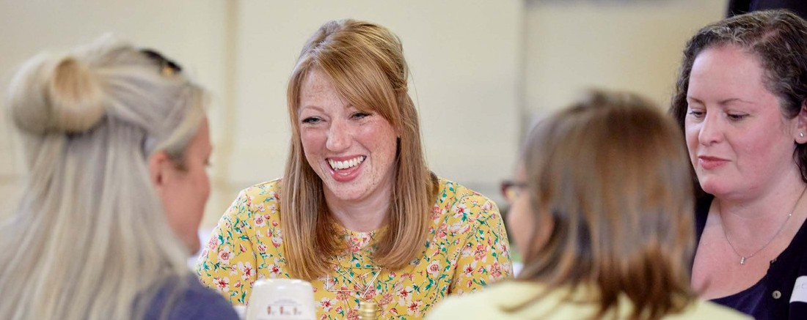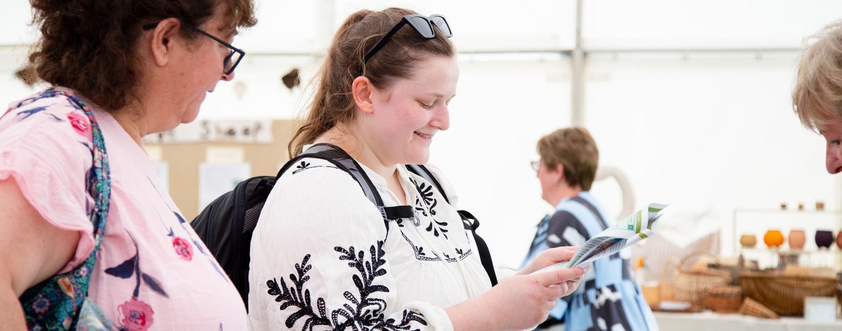

**Photographer: Tasha Best**

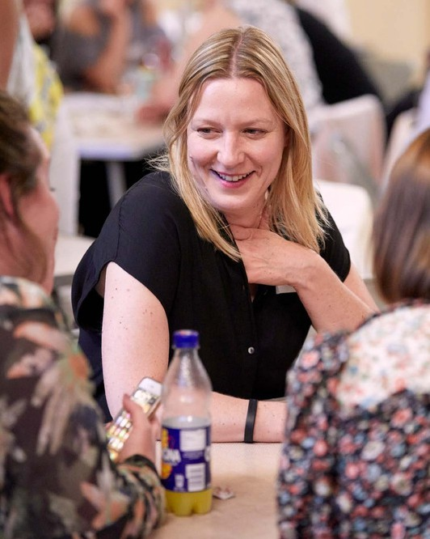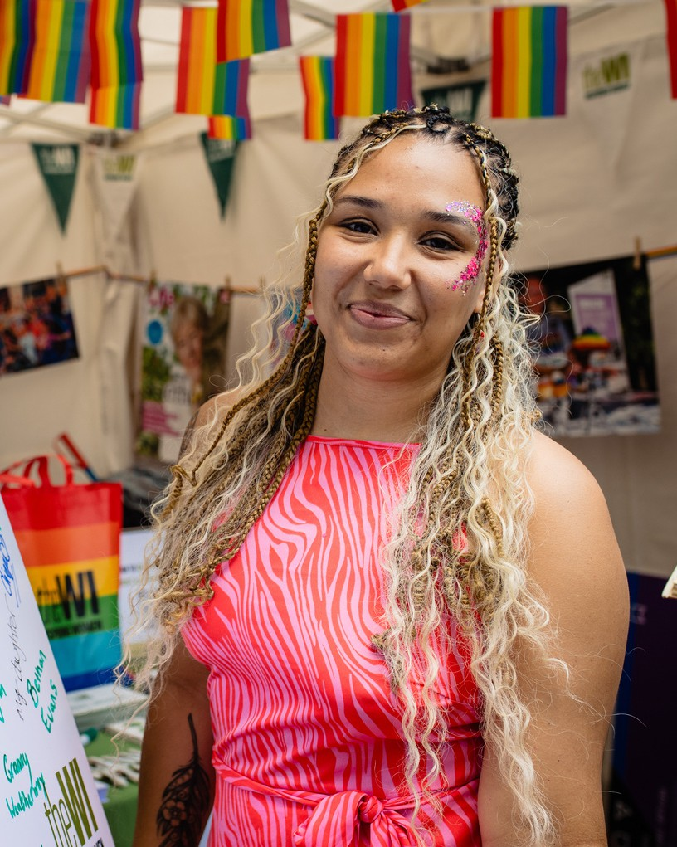

**Photographer: Polly Thomas**

Mailchimp is a marketing automatic platform and email marketing service for managing mailing lists and creating email marketing campaigns to send to people.

It is good for sending out newsletters to both potential members and current members. There are different pricing plans depending on what you would like to use it for.

# WHERE TO LEAVE RECRUITMENT MATERIALS



**Photographer: Lucy Davenport**

|  |  |
| --- | --- |
| **Groups** | **Joint activities** |
| Arts (choir, books, dance) | Dance days, a day where you can learn 2 or 3 different dances.  Local book clubs that can host reading evenings. |
| Local council/community centre | Ask to leave leaflets for the WI at your local community centre. See if you can advertise in their newsletters or packs for new people moving to the area. |
| Craft | Learn a new craft or link in with local craft groups. |
| Education | Engage YFC Farmers in campaigns, local environemnt project, craft and cookery competitions or ‘cook offs’.  Engage with U3A to share resources and learn from each other.  Reach out to teachers at local schools. |
| Mums | Quarterly children’s sessions with their mums.  Open up events to families with a wider age range of children. Please refer to the [NFWI Safeguarding](https://mywi.thewi.org.uk/essential-information/wi-policy-and-guidance/NFWI-Safeguarding-Policy-2025.docx) [Policy](https://mywi.thewi.org.uk/essential-information/wi-policy-and-guidance/NFWI-Safeguarding-Policy-2025.docx). |
| Services - local police, fire, ambulance | Link with them on safety talks and promotion of the WI. |
| Sports | Sports Day.  Reach out to your local rugby club as part of our [Impact 25 project](https://learninghub.thewi.org.uk/category/england-rugby-i25) with England Rugby. |

WI Recruitment Guide WI Recruitment Guide

# RECRUITING VIA LOCAL GROUPS

**8**

**7**

If you have printed materials that you would like to leave around your local area, try these places:

 health care facilities such as doctors surgeries, dentists and chemists

 leisure centres, gyms and swimming pools

 libraries

 local cafes

 local fairs such as craft fairs  post offices

 pubs

 salons including hairdressers and nail bars

 school notice boards for mums and teachers

 shop windows

 supermarket noticeboards  village halls

Please first check with the place that it is okay to leave materials there.

There will be other community groups with similar aims and interests as the WI that you can reach out to. This can be to both recruit new members and arrange joint events. Below are some examples, along with possible joint events to do with different groups.

# RECRUITING AT EVENTS WHERE THE WI HAS A STALL

WI Recruitment Guide WI Recruitment Guide

# DOMAIN NAMES

**10**

**9**

## What is a domain name?

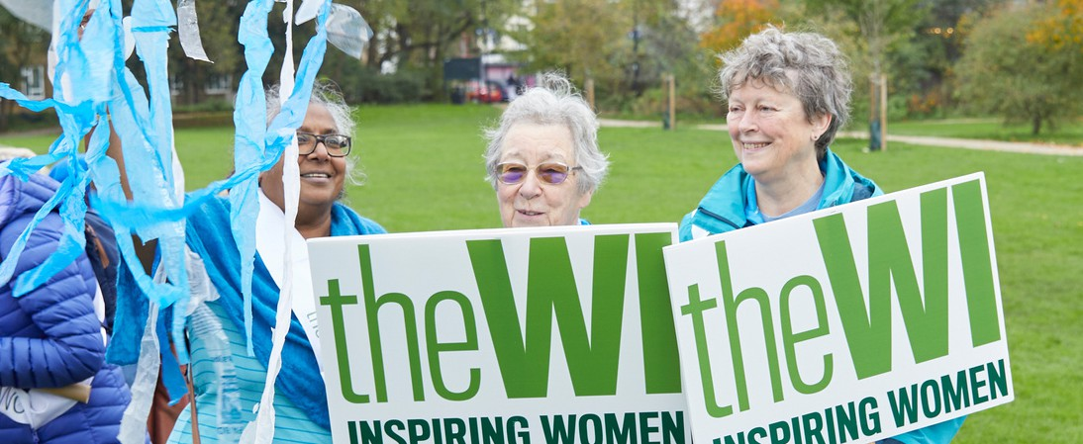

**Photographer: Anne-Marie Bickerton**



**Photographer: Lucy Davenport**

A domain name is an identification within the internet. Domain names are used in various networking contexts and for applying specific naming and addressing purposes, such as ‘@nfwi’. Domain names can be used for websites and email addresses.

## How to create a domain name?

A great way to promote your WI in-person is at events where your WI has a stall. This could be at a local market, a regional event or a show, such as the Knitting and Stitching Show. Follow our top tips for making your stall stand out!

Think about the purpose of the stall. Is the purpose solely to provide information about the WI? Are you holding activities, running a raffle or providing refreshments as well?

Keep text to a minimum and print an titles and meeting details etc clearly. 4.1 gives guidance on this. QR codes are also a good way to save space and could link to your WI’s social media pages or website. Don’t forget to use the WI Logo.

Aim to catch the eye long enough to provide curiosity and a chance to chat or follow up with a request for more information.

Some federations have their own domain name which a WI could use, so check with your local federation whether this is possible.

There’s more than one website to use to create a

domain name, can find the websites by putting ‘how to create a domain name’ in your local search engine, click on one of the links and follow the instructions.

Some of these are free and others require a payment; what you choose to use will depend on what features you would like to include, these will be set out when you click on one of the links.

Keep it simple - decide on the story you wish to tell or a clear message on which to focus. For example, promote the great things about the WI in nine objects. You could link to a particular campaign that is relevant to the people visiting your stand.

Do you have your own WI merchandise you can sell?

When running food stands, please refer to the food safety and hygiene steps.

Don’t feel you have to fill every square centimeter of the available area. The visual impact of your display will be strengthened by leaving some space around it.

## Wording/blurb to explain what the WI is/does

WI Recruitment Guide

WI Recruitment Guide

9. TOP TIPS FOR RECRUITMENT

10. THE WI VISION

**12**

**11**

When asked to describe the WI, it is harder to do than you might think! This is because we do so many amazing things; it is hard to explain what a wonderful organisation we are in a few sentences. Here are some ideas to help you with this. Of course, every WI is unique so make sure you shout about your own WI’s identity and achievements!

The WI is the largest women’s organisation in the UK, and in our inspiring history we have consistently championed the education and rights of women.

## Buzz phrases/words to use when talking to potential members

friendship and fun

you are never alone if you are a member of the WI

self development the WI opens doors me time

feeling part of something

The WI Vision is a great way to tell people what we stand for and what is at the heart of everything we do.

We are a supportive and progressive organisation, and we pride ourselves on being a trusted space for women of all generations to come together to share experiences and learn from each other.

a collective voice on issues that matter to you, women and your community

strength of voice

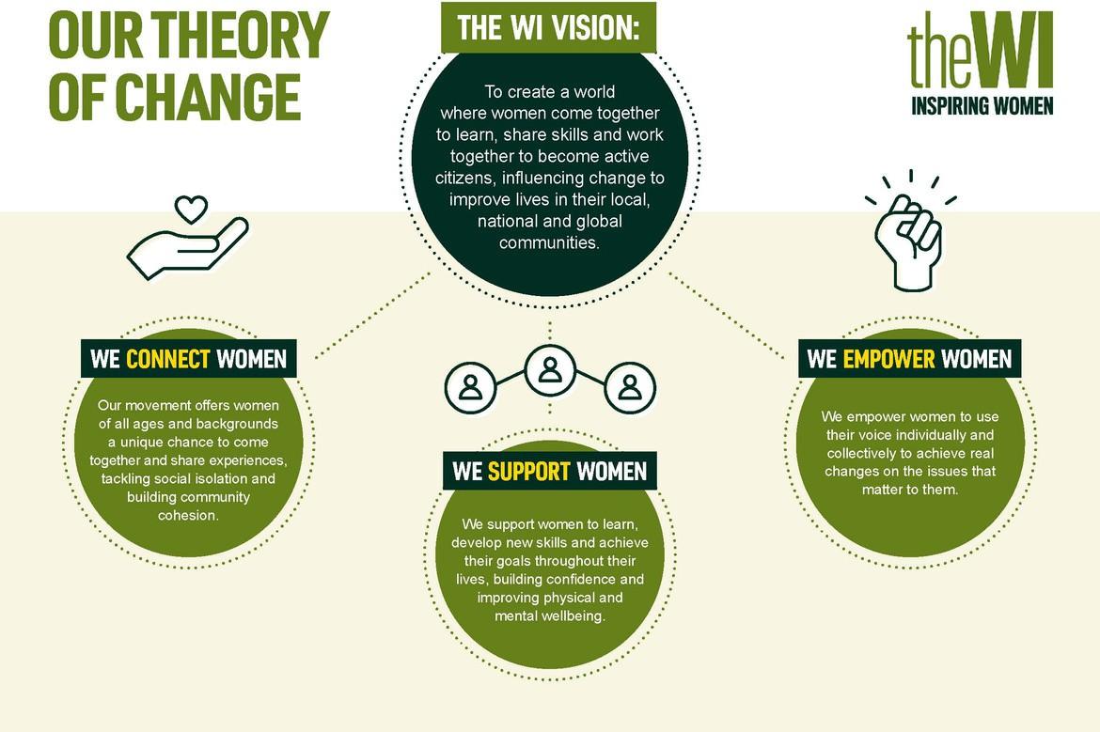

For over 100 years, the WI movement has been instrumental in achieving positive change for women and for society, campaigning on a range of issues from modern slavery to climate change, ADHD and autism in women and girls, and violence against women.

WI members have access to the [WI Learning Hub](https://learninghub.thewi.org.uk/) (online courses) - a range of life-long learning and self-development opportunities across a broad range of topics

inclusive inspiring

WI community WI movement

After you have made the effort to try and get new members at your local WI it is important you

WI Recruitment Guide

WI Recruitment Guide

11. WHAT’S NEXT?

12. OTHER

RESOURCES

**14**

**13**

Follow up with potential members.

Check whether potential members have an accessibility requirements and remember that someone’s accessibility needs can change over time.

Get your WI Welcoming Team to greet them at their first meeting and give them information about the WI.

Follow up with them during the first few meetings to see how they’re doing and if there’s anything the WI could do to improve their experience.

Make sure new members know who they can talk to if there’s anything they need, this might be your WI Welcoming Team or a committee member.

As your WI relies on a continuous flow of new members, it is vital that recruitment is embedded in your WI activities throughout the year.

[Promotional materials](https://mywi.thewi.org.uk/running-your-wi/members-resources/recruitment-materials)[; including editable p](https://mywi.thewi.org.uk/communications-and-pr/publicising-your-wi/promotional-materials)osters and events calendars.

Where possible we recommend using photos of your own members in promotional materials to give a true representation of your WI, the [photography guidance](https://mywi.thewi.org.uk/Publicising-your-WI/resources-and-guidance/photography-guidance) will help you do this.

If you do not have high resolution photos, the photos in the [photo library](https://mywi.thewi.org.uk/Publicising-your-WI/resources-and-guidance/photo-library) on My WI can be downloaded and used.

[The PR Guide](https://mywi.thewi.org.uk/__data/assets/word_doc/0017/700514/NFWI-PR-Guide-2024.docx) can be used when promoting you WI in the media.

Find out how to create a [QR code](https://mywi.thewi.org.uk/Publicising-your-WI/resources-and-guidance/qr-codes).

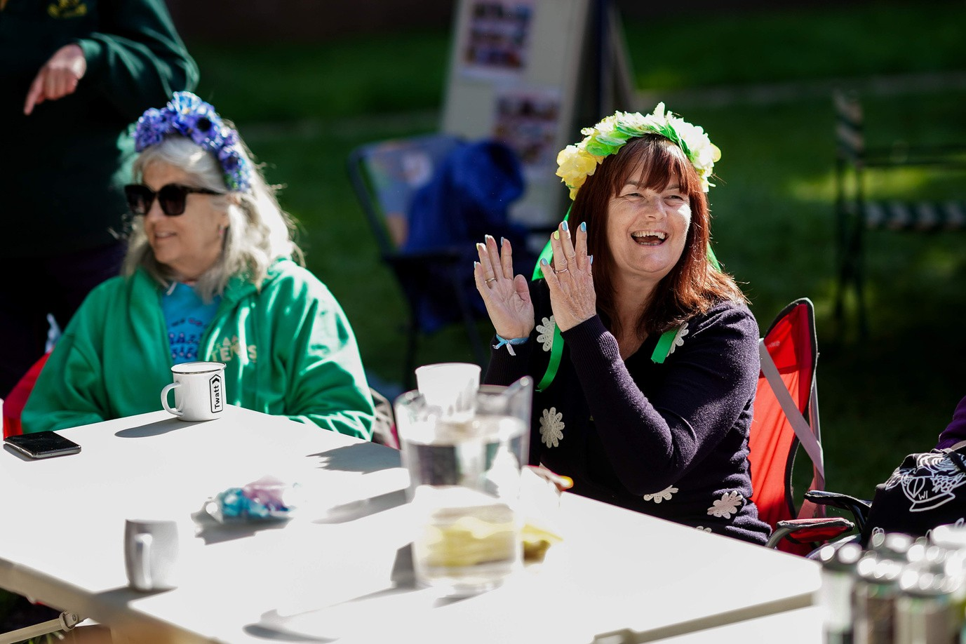Get kitted out in WI merch! Check out the [WI](https://thewi.teemill.com/) [Teemill](https://thewi.teemill.com/) range.

Choosing to shop WI helps our mission, and supports future generations of women, check out our vast range of products at the [WI Shop](https://shop.thewi.org.uk/).

WI Recruitment Guide

14. CONTACT US

**15**

If you would like to contact us about this document, please email [membership@nfwi.org.uk,](mailto:membership@nfwi.org.uk) call 0207 371 9300 or write to us at NFWI, Membership and Engagement Team, 104 New Kings Road, London, SW6 4LY.

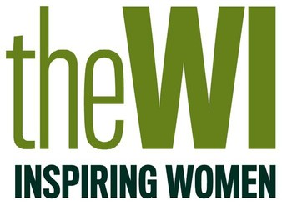

15. Version

|  |  |
| --- | --- |
| Version | 3 |
| Date created | April 2022 |
| Last review date | February 2025 |
| Next review date | February 2025 |
| Document author | Membership and Engagement Team |



Find out more about how you can **be a part of the WI movement:** [**www.thewi.org.uk**](http://www.thewi.org.uk/)

Charity Registration No. 803793

womensinstitute

The WI

womensinstitute

facebook.com/thewi

**Connect WIth us:**